Use Case: Domain-Specific RAG Chatbot Development
Objective
The goal of this project is to design and develop a Retrieval-Augmented Generation (RAG) chatbot that retrieves information from a knowledge base and generates contextual responses using a Large Language Model (LLM).
Students must select a domain based on their interests, identify an information-related problem in that domain, and design a chatbot that helps users retrieve relevant information through natural language interaction.
Tasks to Complete
1. Domain Selection
Students must choose a domain based on their interests and define a clear use case for the chatbot.
They should identify:
- The domain they selected
- The type of information users typically need
- The problem the chatbot aims to solve
The chosen domain will determine the chatbot's knowledge base and functionality.
2. RAG Integration (Retrieval-Augmented Generation)
The chatbot must be able to retrieve relevant information from a document-based knowledge base.
Students should implement the following:
- Allow the chatbot to reference local documents or datasets
- Convert documents into vector embeddings
- Store embeddings for semantic search
- Retrieve the most relevant document chunks when a user asks a question
- Use retrieved information to generate contextual responses using an LLM
3. Live Web Search Integration (Optional)
Students may optionally add a feature that allows the chatbot to perform real-time web searches when relevant information is not available in the local knowledge base.
This feature can retrieve information from the internet and use it together with the LLM to generate responses.
Students who implement this feature should:
- Add a function to perform web searches
- Retrieve relevant information from the results
- Use the retrieved data to assist the chatbot in generating responses
4. Response Modes
The chatbot should support two response styles:
Concise Mode – Provides short, summarised responses containing key information.
Detailed Mode – Provides expanded responses with additional explanation and context.
Users should be able to switch between these modes in the chatbot interface.
Recommended Project Structure
Students should follow a modular project structure similar to the following:
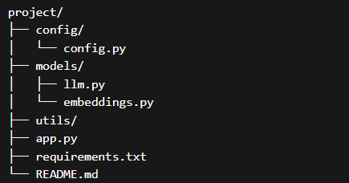
Students may add more files if needed, but the code should remain organised and modular.
Development Guidelines
Students should follow these guidelines during development:
- Maintain clean and modular code.
- Do not push sensitive information such as API keys, tokens, or credentials to the GitHub repository.
- Store API keys and configuration values inside the config/ directory or use environment variables.
- Use reusable functions and keep the code organised inside the appropriate modules.
- Ensure the chatbot works end-to-end before deployment.
Deployment Instructions
- Finalise the chatbot application in app.py
- Deploy the application using Streamlit Cloud or a similar platform
- Ensure the chatbot works end-to-end with document retrieval and response generation
Final Deliverables
Students must submit the following:
1. GitHub Repository
A GitHub repository containing the complete project code.
2. Deployed Chatbot Link
A working, deployed version of the chatbot.
3. Short Document (1–2 pages)
A document explaining:
- The chosen domain
- The problem being addressed
- Why the chatbot is required for that problem

